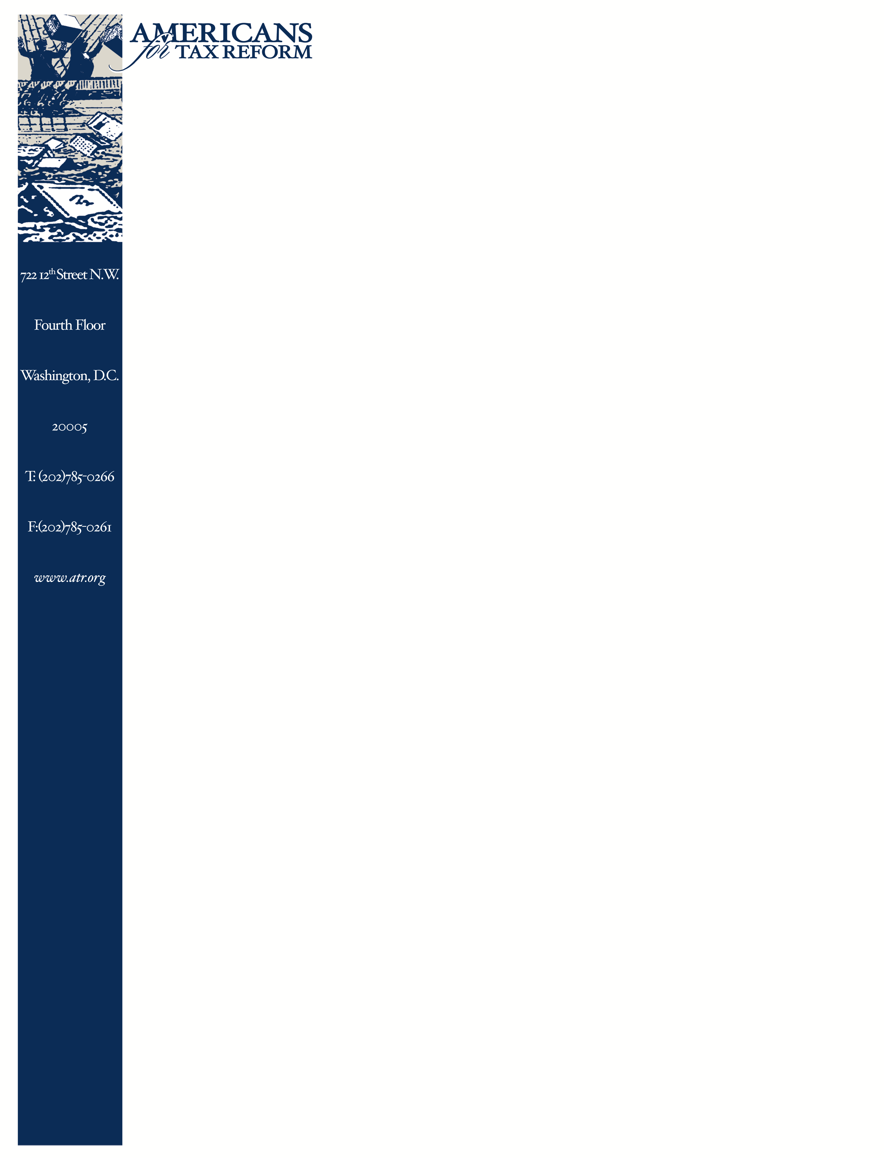
May 13, 2019

Mr. Mark Schlegel
Attorney-Advisory
Financial Stability Oversight Council
1500 Pennsylvania Ave., NW
Washington, DC 20220

Re: Authority to Require Supervision and regulation of Certain Nonbank Financial Companies (RIN 4030-ZA00)

Dear Mr. Schlegel,

I write to applaud the proposed interpretive guidance issued by the Council on March 13, 2019 as a step in the right direction for nonbank financial institutions. My hope is that after comments are reviewed and studied, the Council and its staff will consider avenues beyond guidance alone that would contribute to greater certainty for nonbank financial institutions. I am also interested in presenting constructive input that would provide clarity for nonbank institutions and continuing the dialog to address perspectives ATR values in a finalized version.

The Financial Stability Oversight Council was established by Dodd-Frank with the purpose of harmonizing communication and oversight between multiple federal agencies, state-based regulatory bodies and an independent insurance expert and is chaired by the Treasury Secretary. The Council has the ability to designate certain bank holding companies, non-bank institutions and financial market utilities as systemically important financial institutions. The two most prominent factors for SIFI designation include an institution’s leverage and interconnectedness with other SIFI institutions.

With the heightened oversight associated with a SIFI designation, I applaud two important steps the Council has taken to provide additional clarity for nonbank financial institutions and kindly offer three additional suggestions for consideration in
a finalized package. I believe it is important to consider the current regulations that were designed for oversight purposes of certain financial institutions like bank holding companies instead of nonbank institutions, and the affect these regulations have on institutions in terms of compliance. For example, AIG - a nonbank designated SIFI - was subject to the Federal Reserve’s Large Institution Supervision Coordinating Committee and underwent “stress test[ing]”, or the Comprehensive Capital Analysis and Review, a regulatory framework more closely associated with large bank holding companies. It would be helpful if FSOC and the regulatory staff supporting the Council’s members discussed what regulations already exist for these nonbank institutions to comply with, and which, if any, additional regulations these institutions would be subject to as a SIFI. These discussions should also take into consideration the interconnectedness of the nonbank institution to other financial institutions.

I am supportive of and welcome the addition of a cost-benefit analysis in the current proposal. It would be helpful if FSOC considered incorporating two measures to be included in the cost-benefit analysis. In addition to the costs associated with compliance through the institution’s primary regulator and enhanced regulation resulting from a SIFI designation, I believe it would be constructive to also consider the indirect costs associated with designation. These indirect costs include loss of shareholder value, costs associated with financial products available to customers and the loss of competition in the marketplace between competing institutions and the advantage those not subject to SIFI oversight would have over institutions that are designated. By considering these indirect costs, the Council could be in a better position to move forward with a designation or not.

The second aspect of the proposal that deserves praise is the requirement that the Council must first consult with the nonbank institution’s primary regulator throughout the designation process. More importantly, the proposal allows the lead regulator to propose a different oversight approach and allows the nonbank institution to offer its own solution for the Council to consider. If the Council is not satisfied with solutions provided by the primary regulator and institution itself, only then can the Council designate the institution as a SIFI. This approach reserves the SIFI designation as a last resort option after other options for correcting the institution’s best practices are exhausted. Similarly, Senator Rounds (R-S.D.) has introduced legislation in the 115th Congress and recently in the current Congress that would codify this provision, creating greater certainty for nonbank institutions. I am proud to offer my support for his current legislation, S.603, and would encourage the Council to keep this provision in any finalized version of the proposal.

Mr. Schlegel, I would like to thank you for your leadership on this issue as the proposed guidance is an important step that provides greater transparency and accountability for the nonbank SIFI designation process. I would also ask the Council to consider any additional pathway beyond guidance alone to help solidify the certainty created in the proposal for nonbank institutions, including recommending to the Federal Reserve Bank to exercise its statutory obligations under Section 170 of the Dodd-Frank Act to exempt from designating those types of nonbank financial companies that do not exhibit risk factors for designation. I applaud your initiative and am looking forward to working with you on this issue.

If you should have any questions or comments, please contact me or James Setterlund by phone, 202-785,0266, or email, jsetterlund@atr.org.

Sincerely,
Grover G. Norquist
President, Americans for Tax Reform

CC: The Honorable Steven T. Mnuchin, Secretary, Department of the Treasury
Bimal Patel, Deputy Assistant Secretary for the Council
Eric Froman, Principal Deputy Assistant General Counsel (Banking and Finance) and Executive Director of the Council
Stephen Ledbetter, Director of Policy, Office of the Financial Stability Oversight Council

Postal, Arthur D., Think Advisor, AIG Preparing for Federal Regulation: AIG is Making Moves as a SIFI to Bulk up its Capital, May 6, 2014, https://www.thinkadvisor.com/2014/05/06/aig-preparing-for-federal-regulation/
Sen. Rounds, Mike, S. 3577, Financial Stability Oversight Council Improvement Act of 2018, Oct. 11, 2018, https://www.congress.gov/bill/115th-congress/senate-bill/3577/text
Sen. Rounds, Mike, S. 603, Financial Stability Oversight Council Improvement Act of 2019, Feb. 28, 2019, https://www.congress.gov/bill/116th-congress/senate-bill/603/text
Norquist, Grover, G. ATR Supports Sen. Rounds’ (R-S.D.) FSOC Improvement Act, April 29, 2019, https://www.atr.org/sites/default/files/assets/LoS%20-%20Rounds%2C%20FSOC%20Improvment%2C%20April%202019.pdf

